Experiential Learning

Freudian Psychological Society
ACTIVITIES AND EVENTS (2022-2023):
- Date:10th September 2022
Resource Person:Dr.Davinder Singh Johal, Associate Professor and Head of Department of Psychology, GNDU, Amritsar
Activity:World Suicide Prevention Day was observed
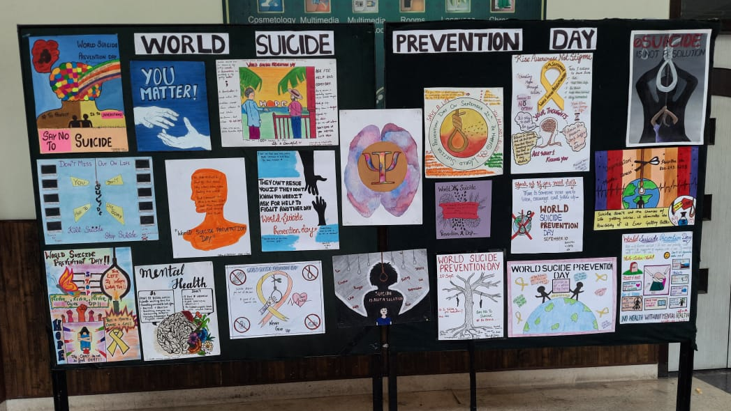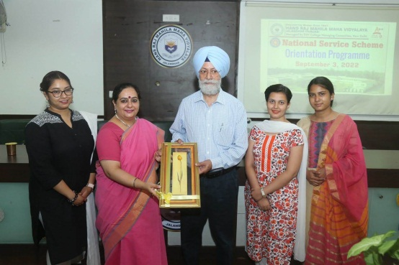

- Date:1st October 2022
Resource Person:Ms.RamandeepKaur, Counselling Psychologist
Activity: Workshop on “Drug Abuse: Problem and Prevention”
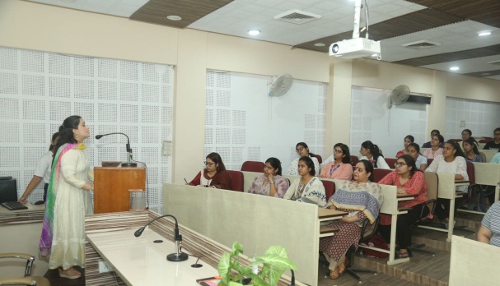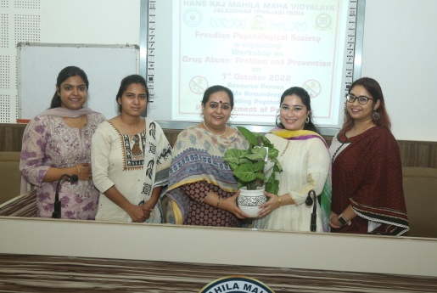

- Date: 10th October 2022
Resource Person: Mrs TarveenKaur, Life Coach and Inspirational Speaker
Activity: On the Occasion of World Mental Health Day, workshop on ‘Building Positive Mind-set’ was organised
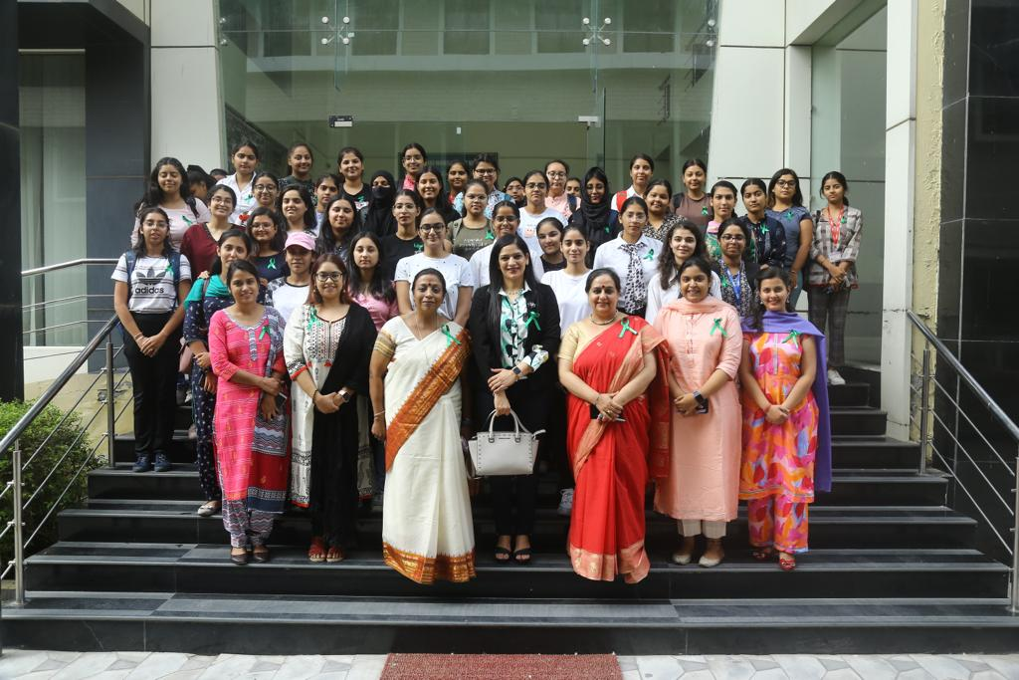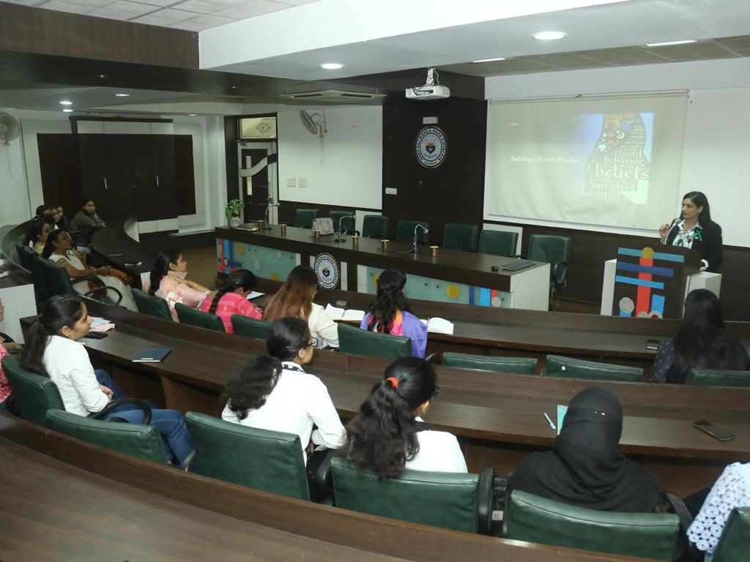

- Date:11th November 2022
Resource Person: Mr AtulMadaan, Clinical Psychologist, NHS, Jalandhar
Activity: Workshop on ‘Understanding IQ: An Essential Component For Psychology Students’
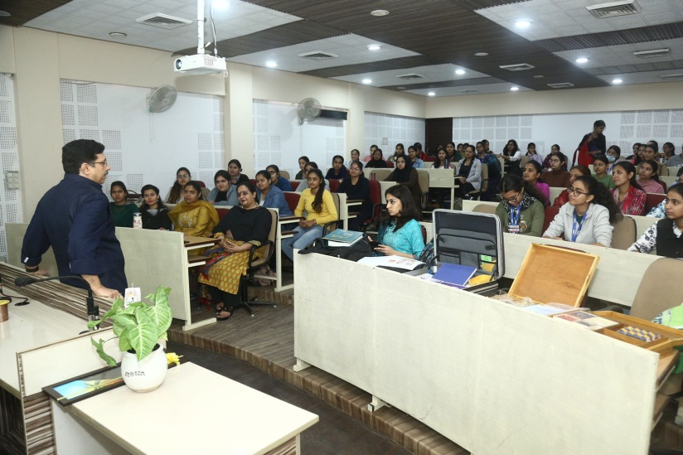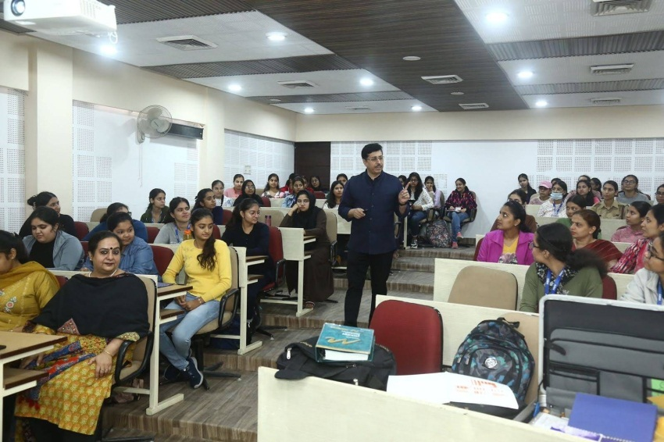

- Date: 14th November 2022
Resource Person: Ms KomaldeepKaur, Clinical Psychologist, Sahara Psychiatry and De-addiction Hospital, Bhogpur
Activity: Workshop: Cognitive Behaviour Therapy
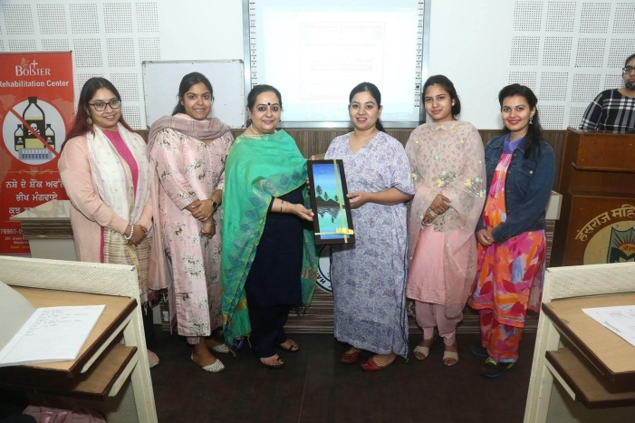

Participative Learning

- Date: 3rd December 2022
Activity: World Disability Day Observed
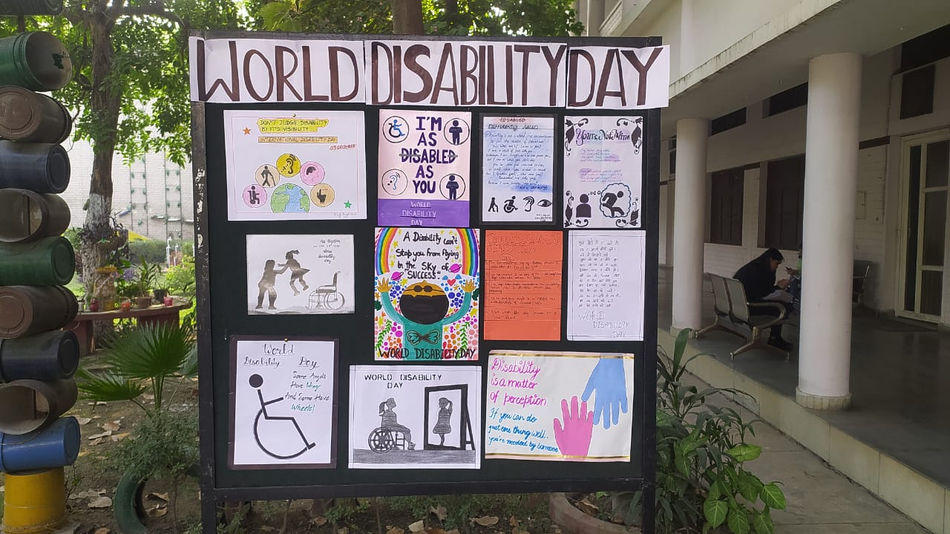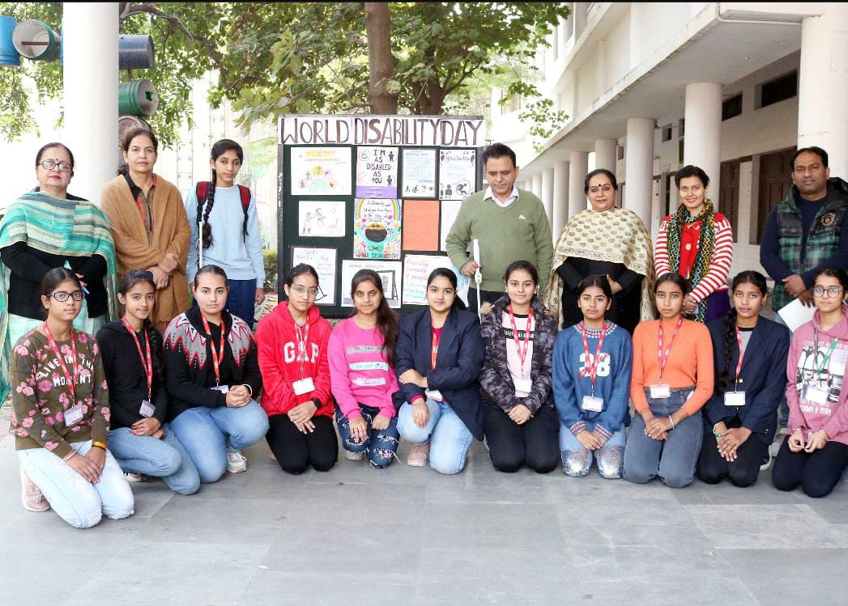

- Date:10th February 2023
Resource Person: Mr AtulMadaan, Clinical Psychologist and Chief Advisor, Care for Autism Foundation
Activity:Educational Visit to Care for Autism Foundation, Jalandhar
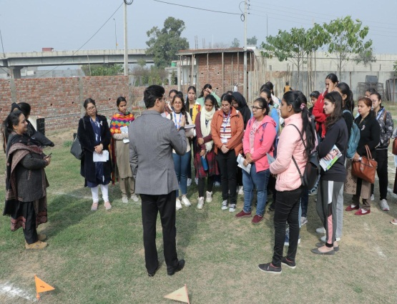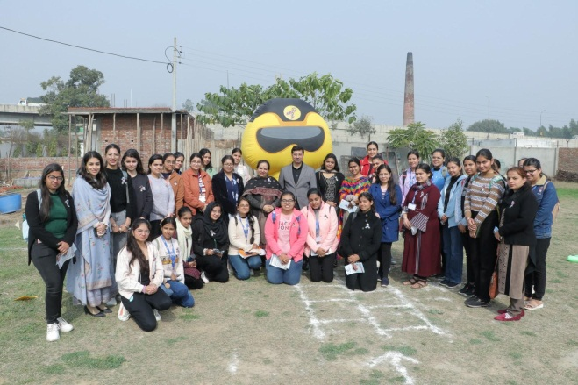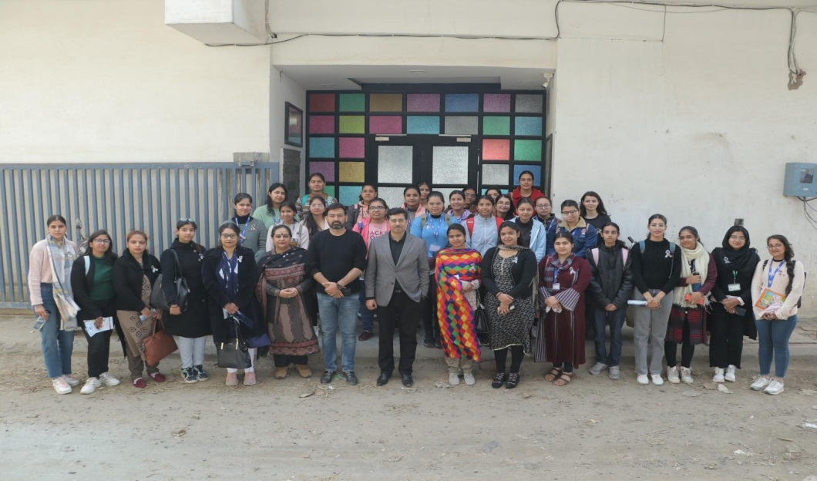

- Date: 10th March 2023
Resource Person: Mrs Grace Daniels, Internationally Certified Brain Gym Instructor, Special Educational Needs Coordinator, Cambridge School, Jalandhar
Activity:Workshop on Introduction to Brain Gym for Psychology Students

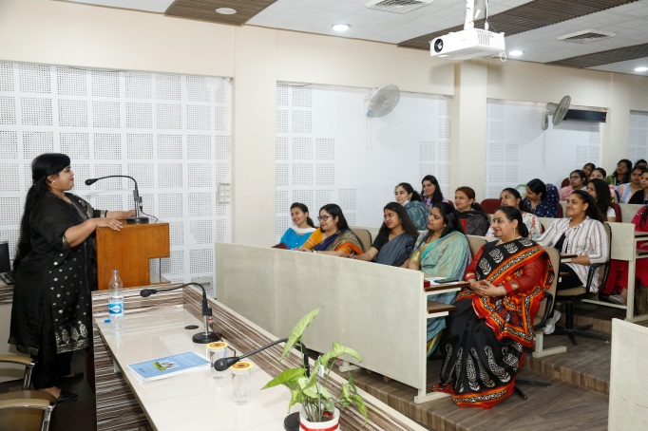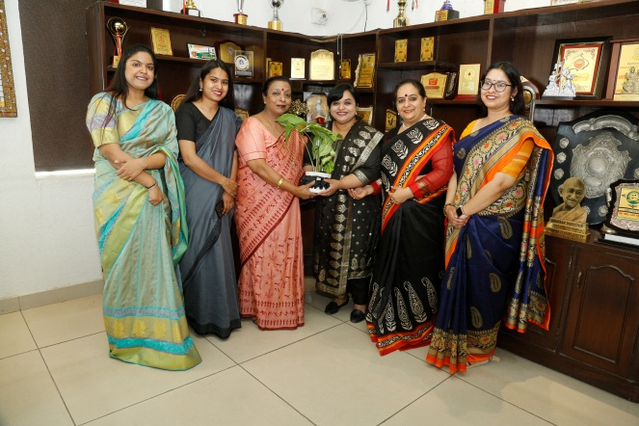

- Date:22nd March 2023
Resource Person: Ms DaminiTewari, Deputy Counselling Psychologist
Activity:Workshop on Building Resilience and Self confidence
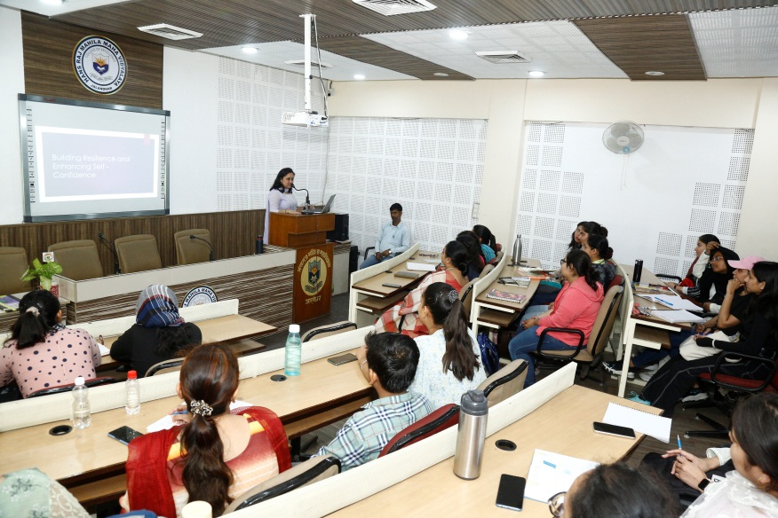
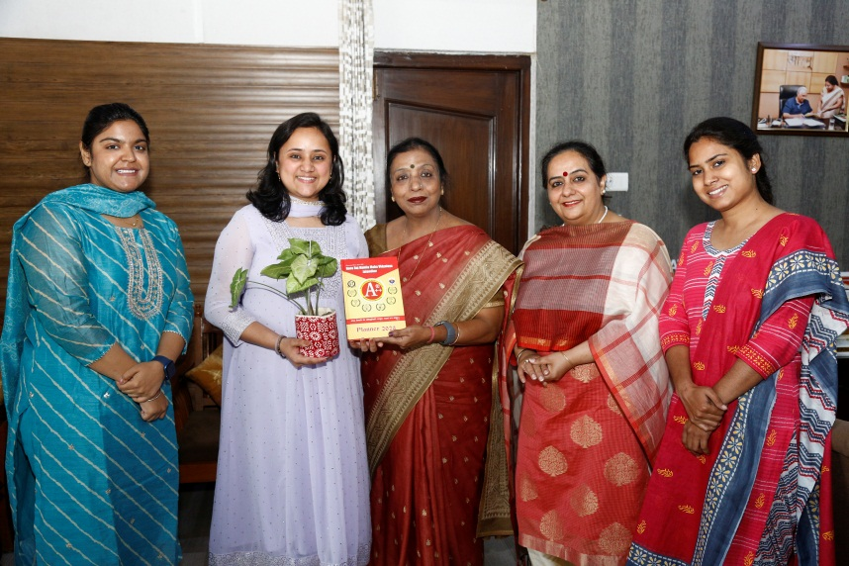

- Date: 25th March 2023
Resource Person: Col. Ajay Singh Dali
Activity:Workshop on The Leadership Tao
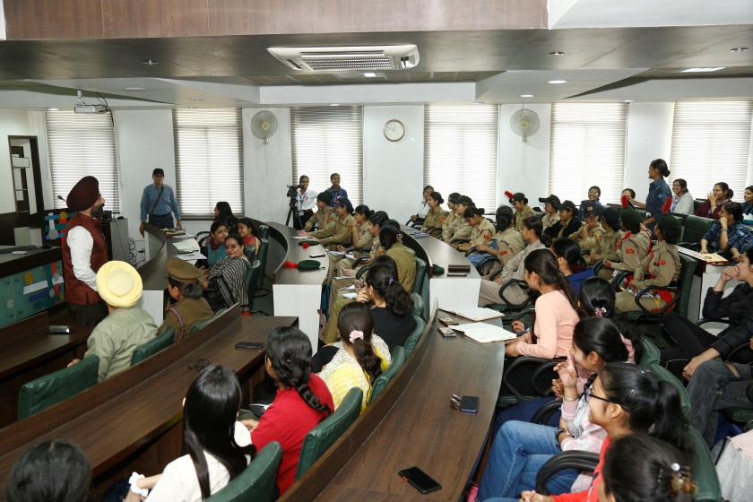
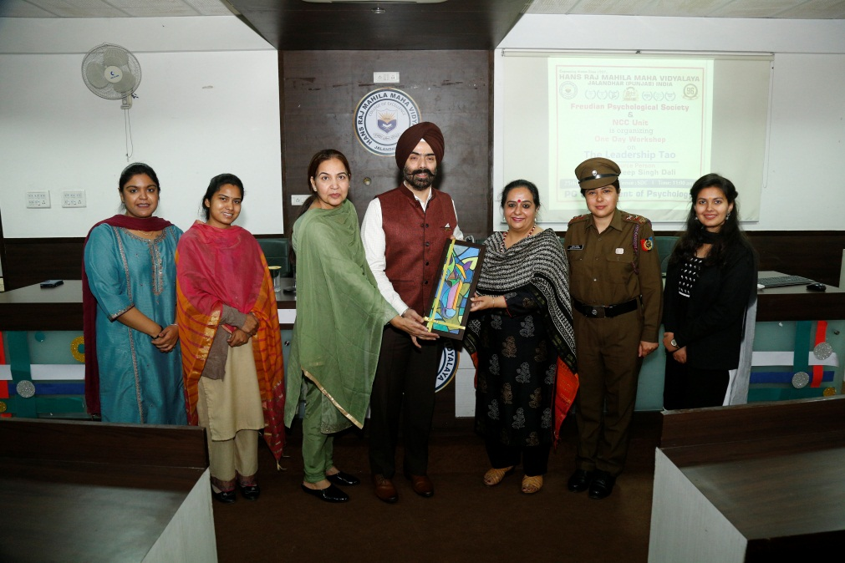

- Date: 10th April 2023
Resource Person: Ms Vaishaly , Founder , Psykey
Activity:Workshop on Positive Psychotherapy
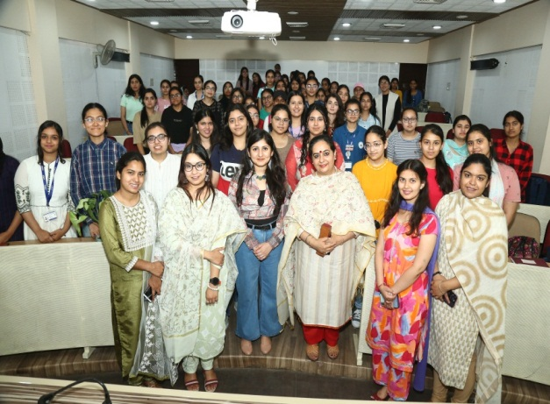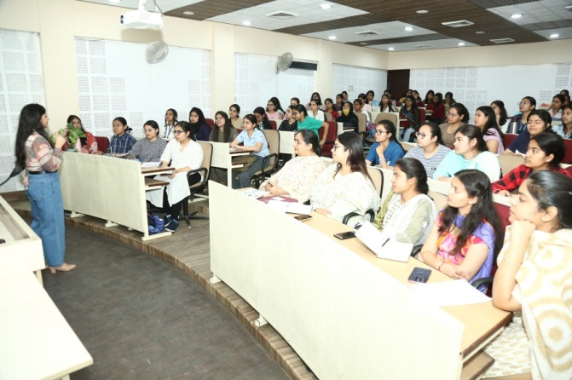
- Date: 18th March 2023
Activity:Visit to Golden Temple, JalianwalaBagh, Gobindgarh Fort, Amritsar
